MARTIN M. LOONEY
PRESIDENT PRO TEMPORE OF THE STATE SENATE
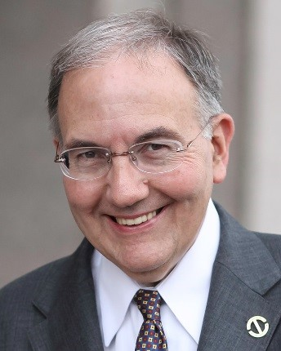
Martin Looney currently is in his seventeenth term, having been elected to the State Senate in 1992, following six terms as a State Representative. In January of 2015, Senator Looney was elected by the members of the State Senate to serve as President Pro Tempore, the highest-ranking legislator in the Connecticut General Assembly. He was re-elected to that position in January of 2017, January 2019, January 2021, January 2023, and again in January 2025.
Prior to his election as Senate President, Senator Looney served 12 years as Senate Majority Leader. Prior to becoming Majority Leader, he served three terms as Senate Chair of the Finance, Revenue and Bonding Committee; one term as Senate Chair of the Banks Committee; and one term as the Senate Ranking Member of the Judiciary Committee.
During his six-term tenure as State Representative, beginning in 1981, Senator Looney was appointed an Assistant Majority Leader and served as House Chair of the Planning and Development Committee, the Government Administration and Elections Committee, and the Appropriations Judicial Subcommittee, and as Vice Chair of the Judiciary Committee.
Senator Looney has received many awards and accolades, including the 2013 Connecticut Trial Lawyers Association Civil Justice Award, the 2014 Coalition Crusader Award for work with domestic violence issues, the 2014 National Coalition for Capital Champion of Small Business Award, the 2015 AARP Capitol Caregiver Award, the 2017 CT Probate Assembly Public Service Award, the 2017 CT Bar Association Special Recognition Award, and the 2023 Legislative Beacon of Light Award from the Connecticut AFL-CIO for outstanding commitment and dedication to the working people of Connecticut.
Other associations that have honored the Senator include: The American Lung Association, Autism Speaks, CT Association for Human Services, the CT Dental Association, the MS Society, Coalition for Working Families, CT Society of Eye Physicians, Cornell Scott-Hill Health Center, Youth Continuum, Hospital of St. Raphael, ACES, Life Haven, New Reach, the Connecticut Kidney Association, and the Fair Haven Community Health Center.
Senator Looney is a graduate of Saint Rose School in New Haven, Notre Dame High School in West Haven, and is a cum laude graduate of Fairfield University, where at commencement he was awarded Departmental Honors in English and Theology. He was selected as a National Woodrow Wilson Fellow for graduate study and earned a master's degree in English from the University of Connecticut. He was also awarded an honorary degree from the University of New Haven in 2015.
He received his J.D. in 1985 from the University of Connecticut School of Law and, since his admission to the Connecticut Bar in 1985, has been engaged in the general practice of Law. He is a partner in the law firm of Keyes and Looney. He is also a practitioner in residence with the Criminal Justice Program in the Department of Public Safety at the University of New Haven and is an adjunct faculty member in the Political Science Department at Quinnipiac University and also at Quinnipiac University Law School.
Senator Looney resides in New Haven with his wife, Ellen. They have one son, Michael, and are proud grandparents to Matthew, Anna Katherine, and Isabel Grace.

